List of things added in Project:

1. Springboot with JPA

2. Swagger

3. Tested all the CRUD operations on Postman in Local

4. Added Spring Security for Authentication and Authorization

5. Added Redis Cache

6. Added JUnit

7. Created a maven build

8. Created a MySql database.

9. Created AWS- RDS and added data to its DB instance.

10. Created Beanstalk application environment and deployed the application successfully.

11. Created Elastic cache –Redis in AWS.

Aws RDS Database creation

<https://979427354379.signin.aws.amazon.com/console>

Create RDS DB on AWS.amazon.com

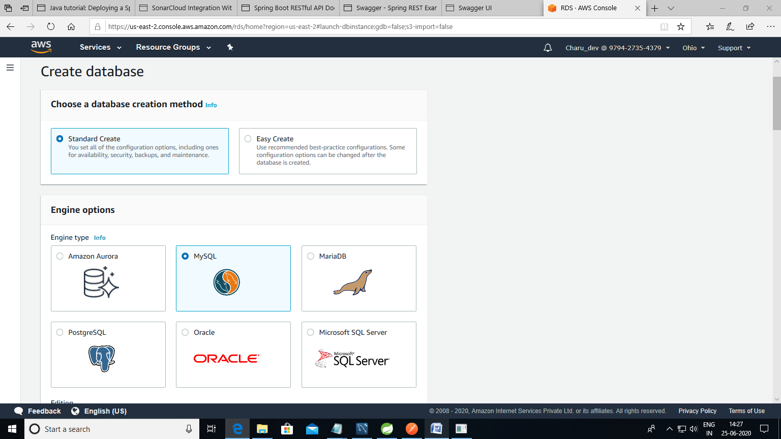

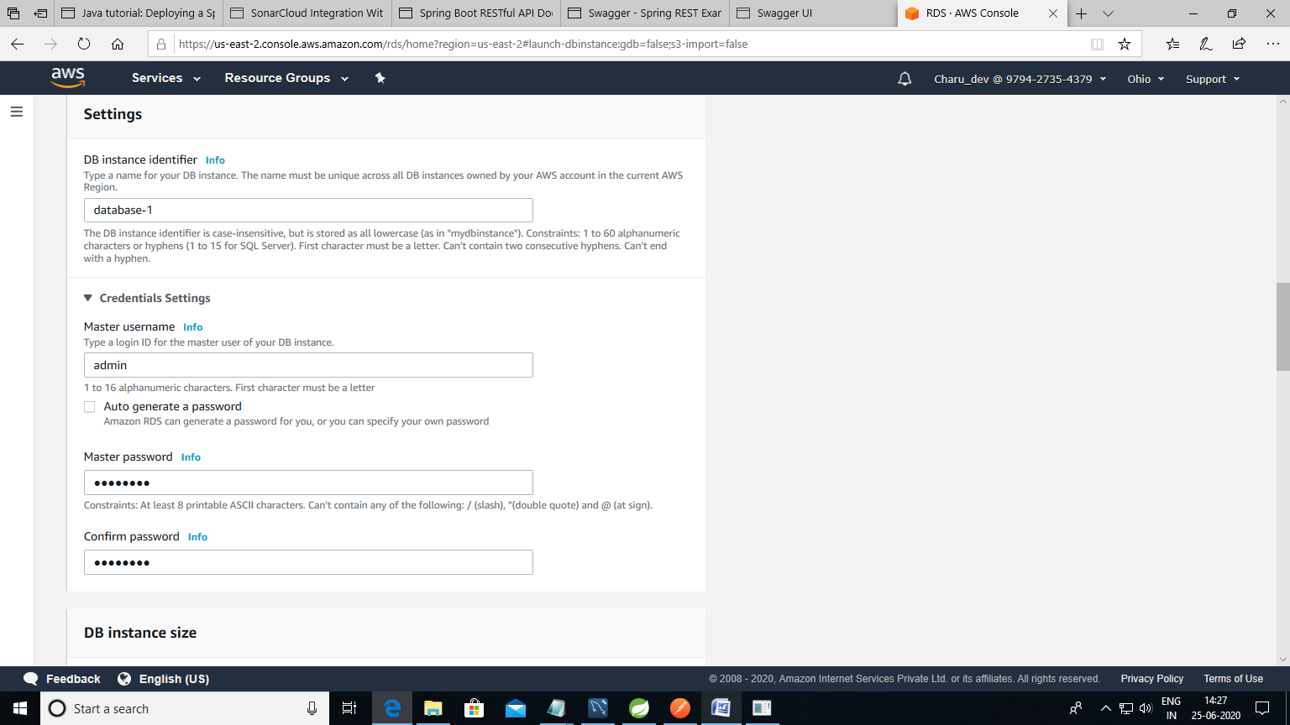

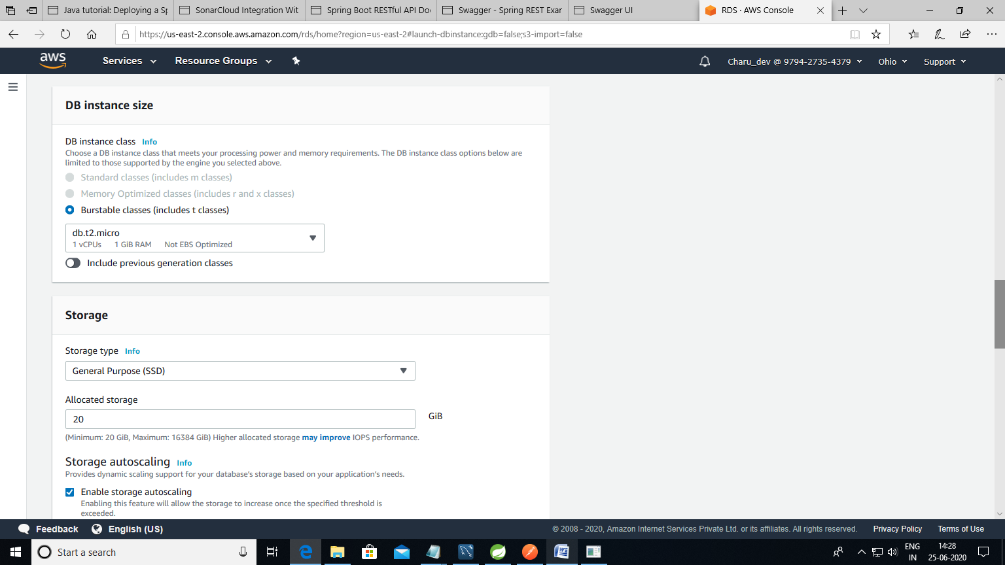

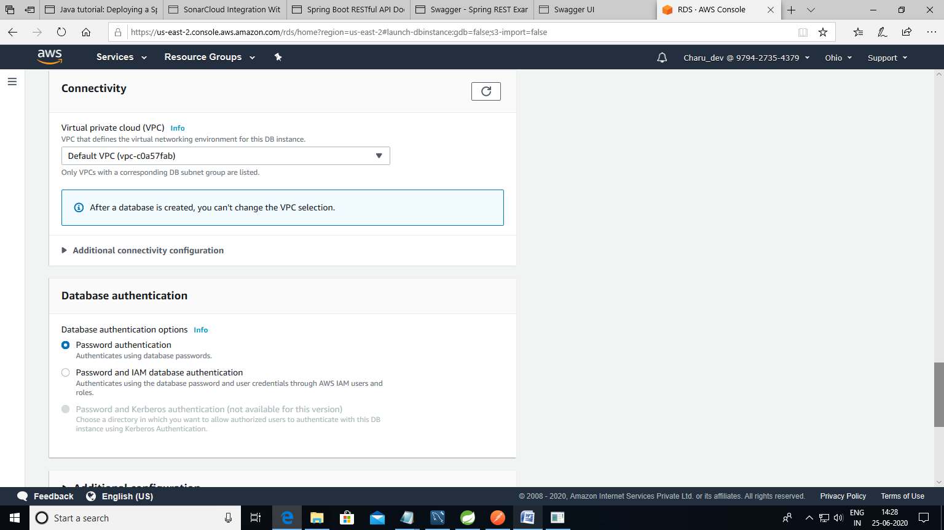

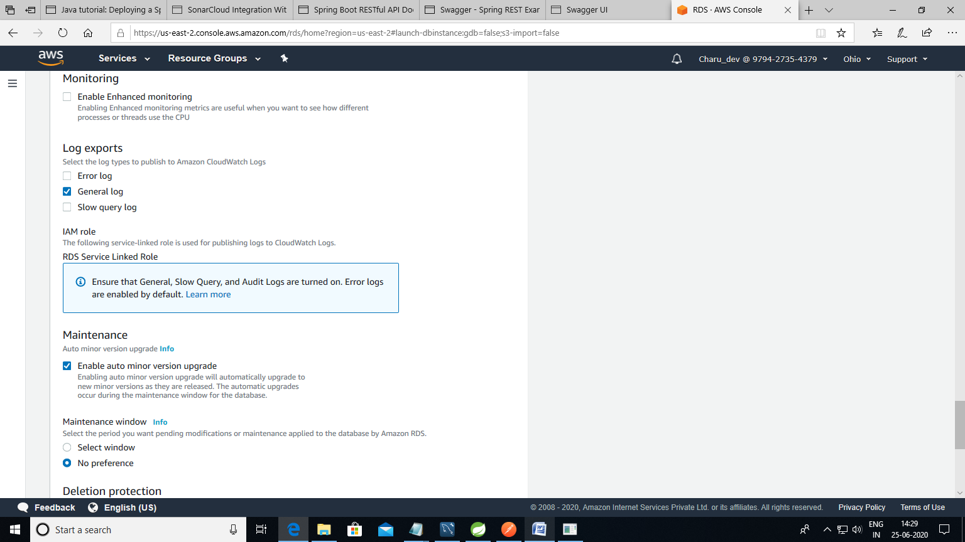

Database created successfully –database1

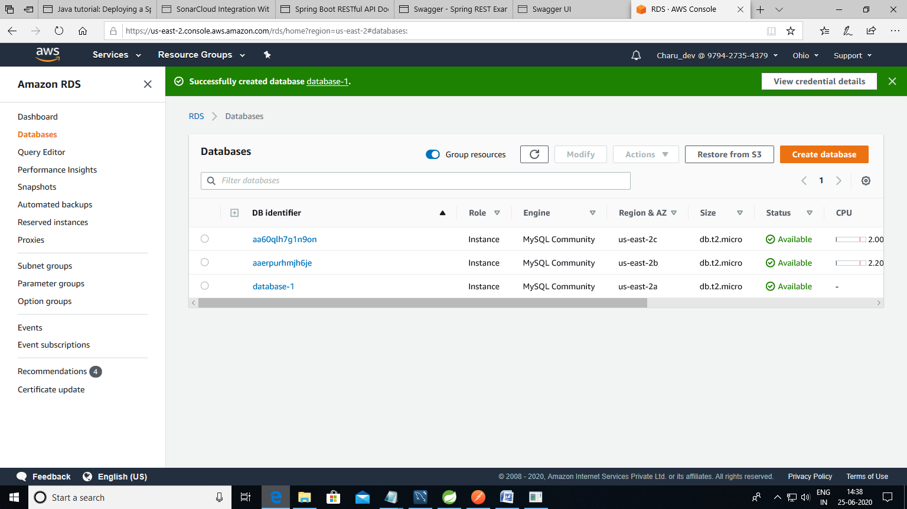

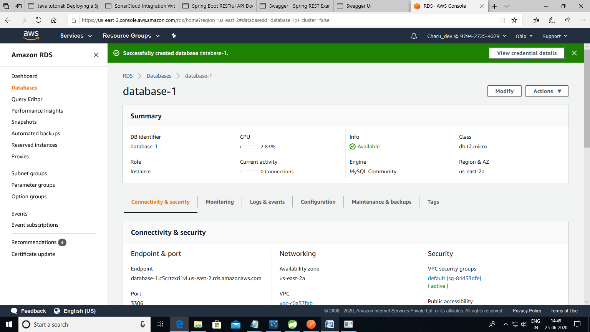

Amazon Beanstalk

Created application and deployed successfully

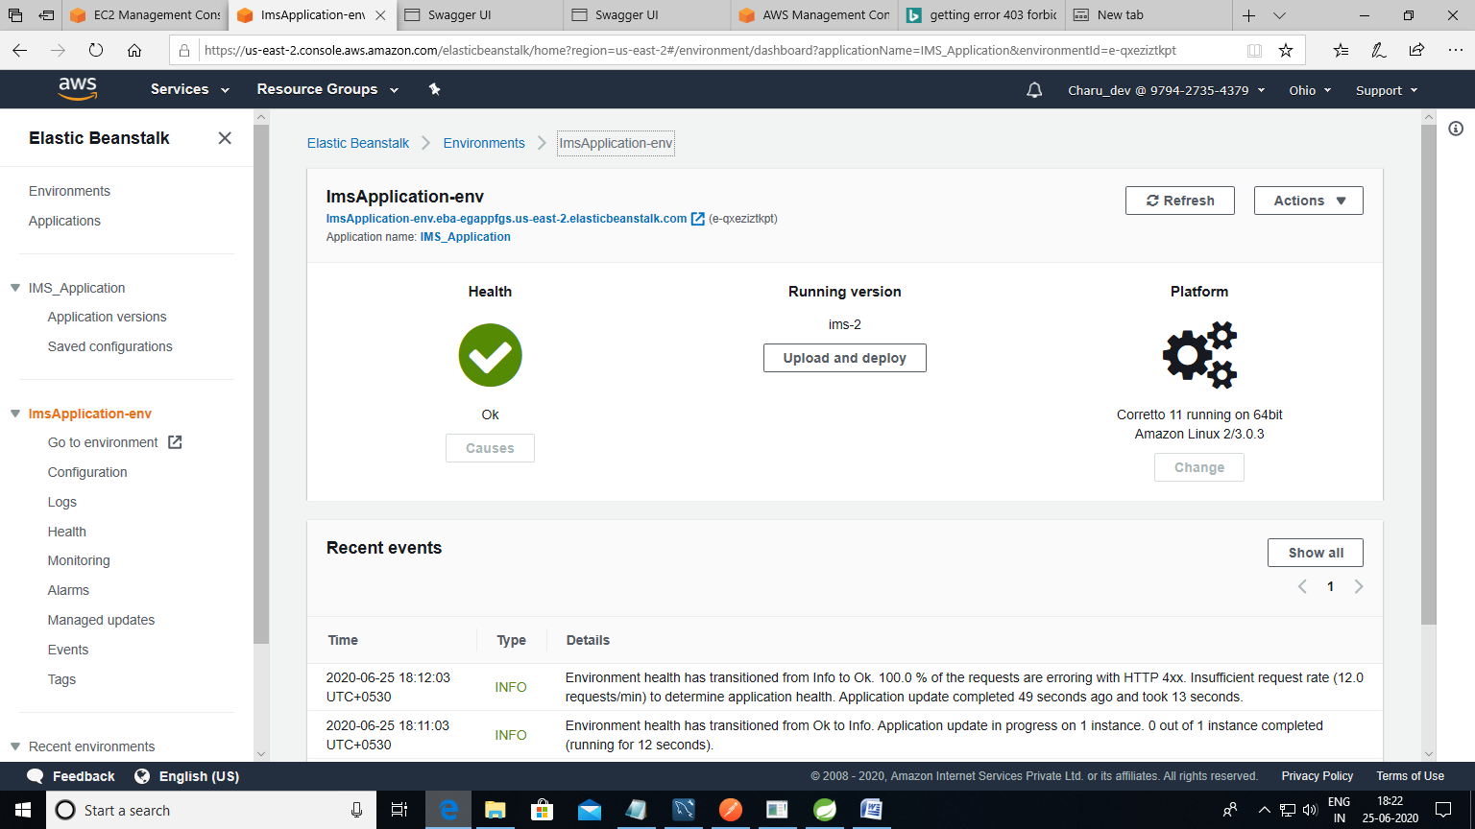

Link to access application:

imsapplication-env.eba-egappfgs.us-east-2.elasticbeanstalk.com/swagger-ui.html/

username: admin1

password: secret1

After logging in:

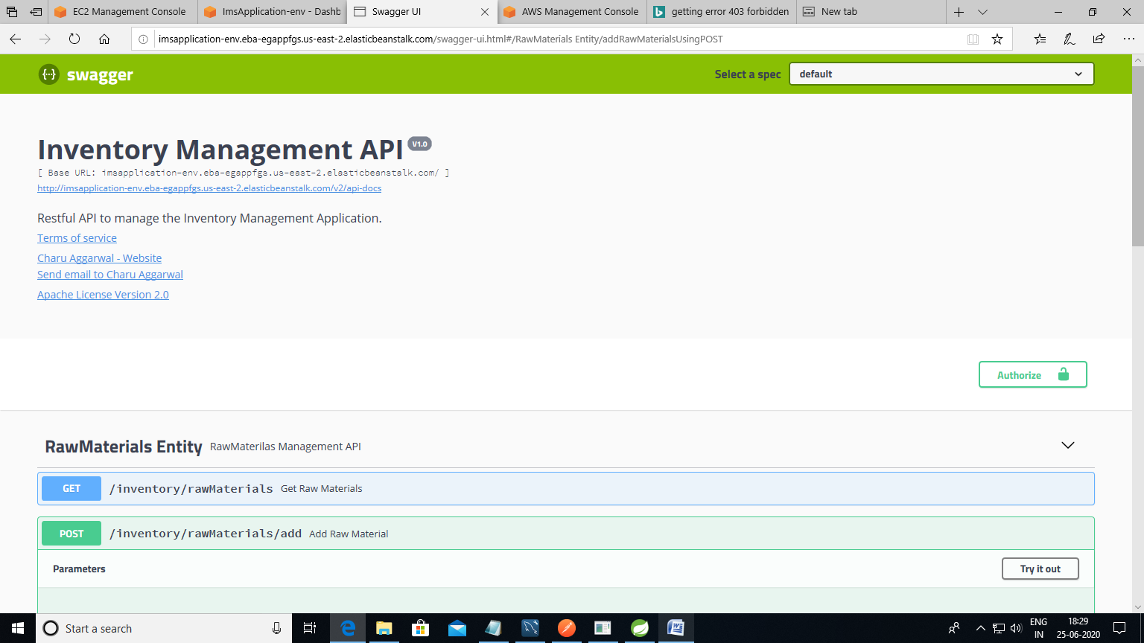

Added data into the Mysql table using swagger.

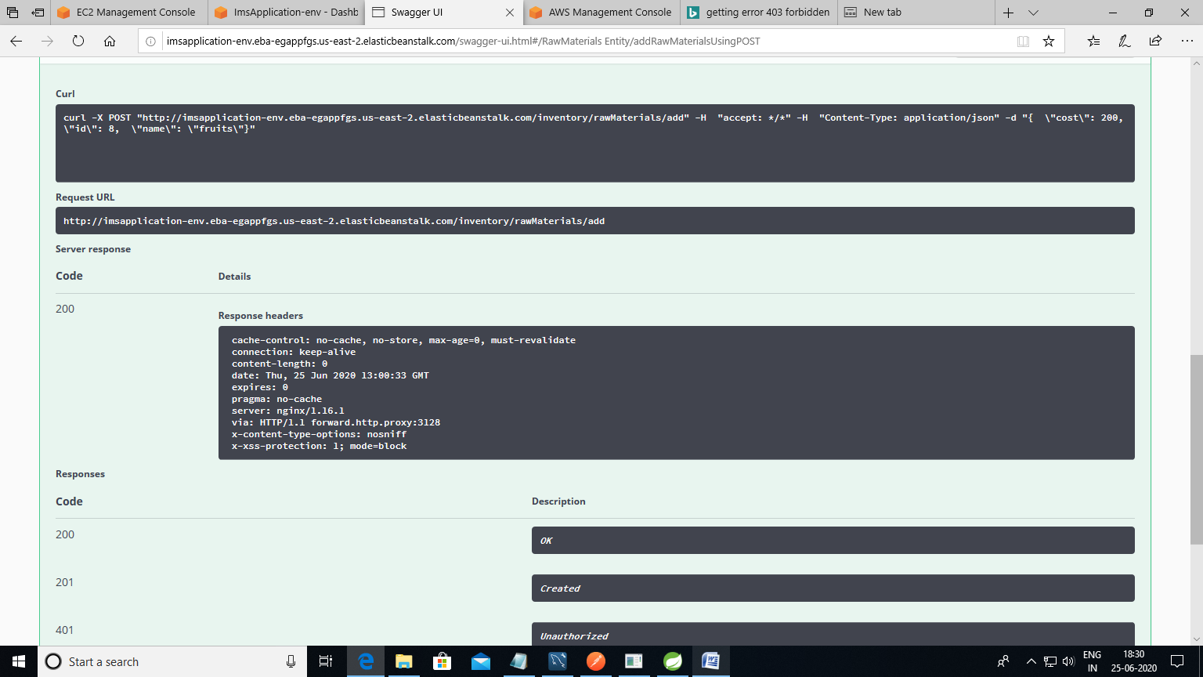

Values saved in database:

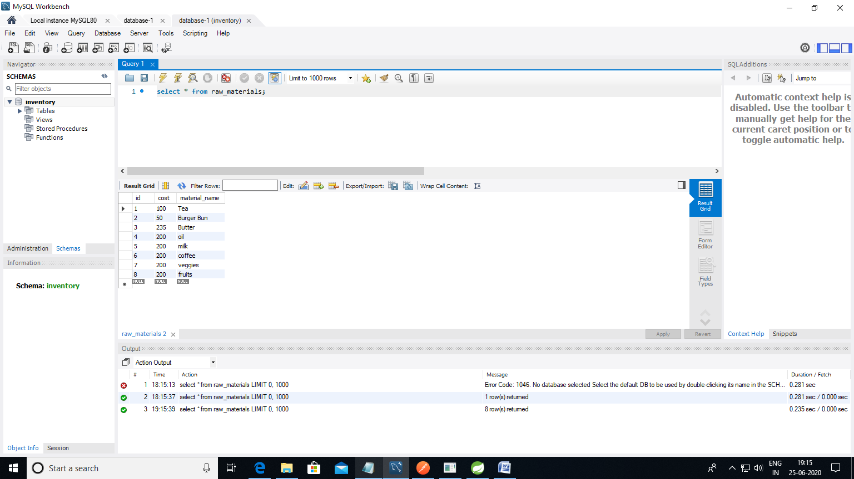

Redis cache in AWS:

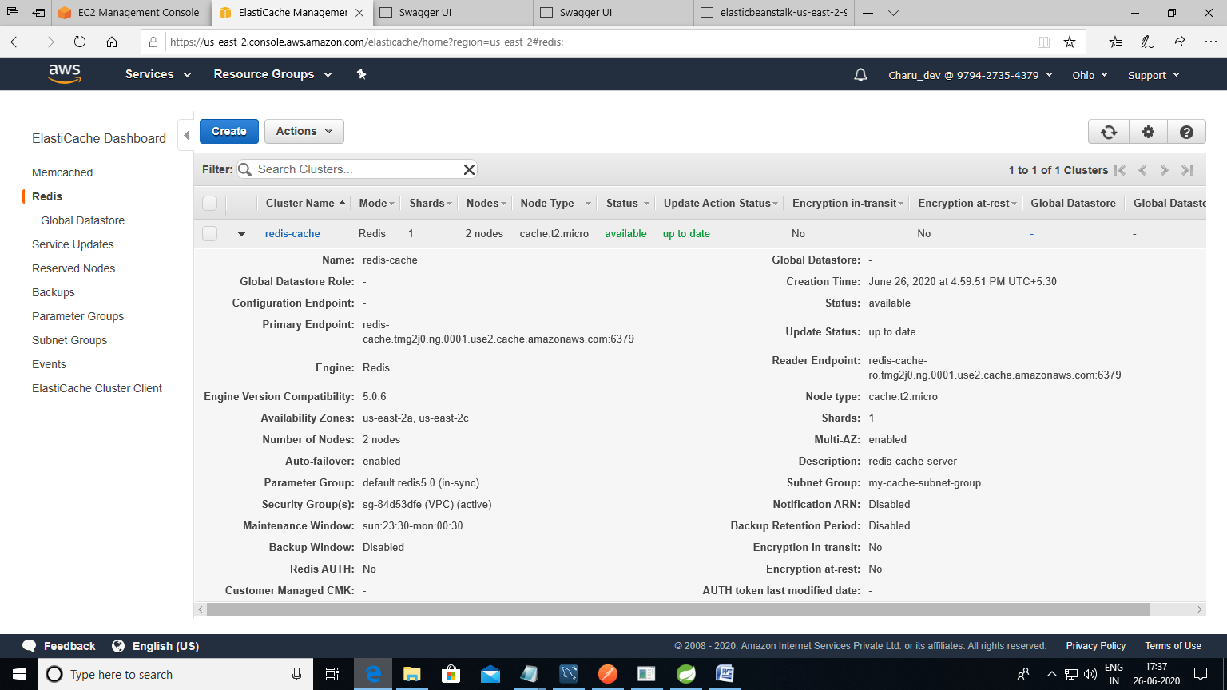

Postman with basic authentication:

